Benchmarking Scope Definition 22.02.2024

Workflow decisions tab – Add new tick box below ‘This is a priority project’

‘This is a benchmark project’ only editable by Global Admin (during credit and project phases)

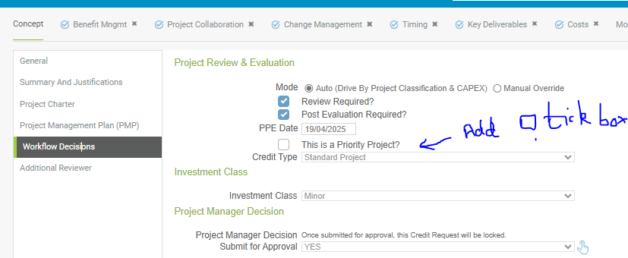

Benefit Management tab - Sustainability widget – add line

C13 – Remaining CO2 after project Units Tons/year

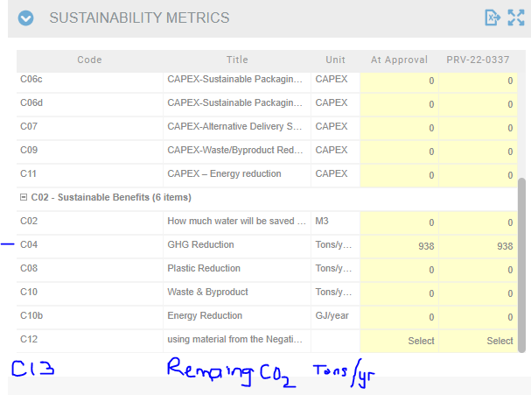

INV05 Dashboard – Sustainability Reporting – add a column in the ‘For export’ table – Remaining CO2 from the new field in the Sustainability Metrics widget.

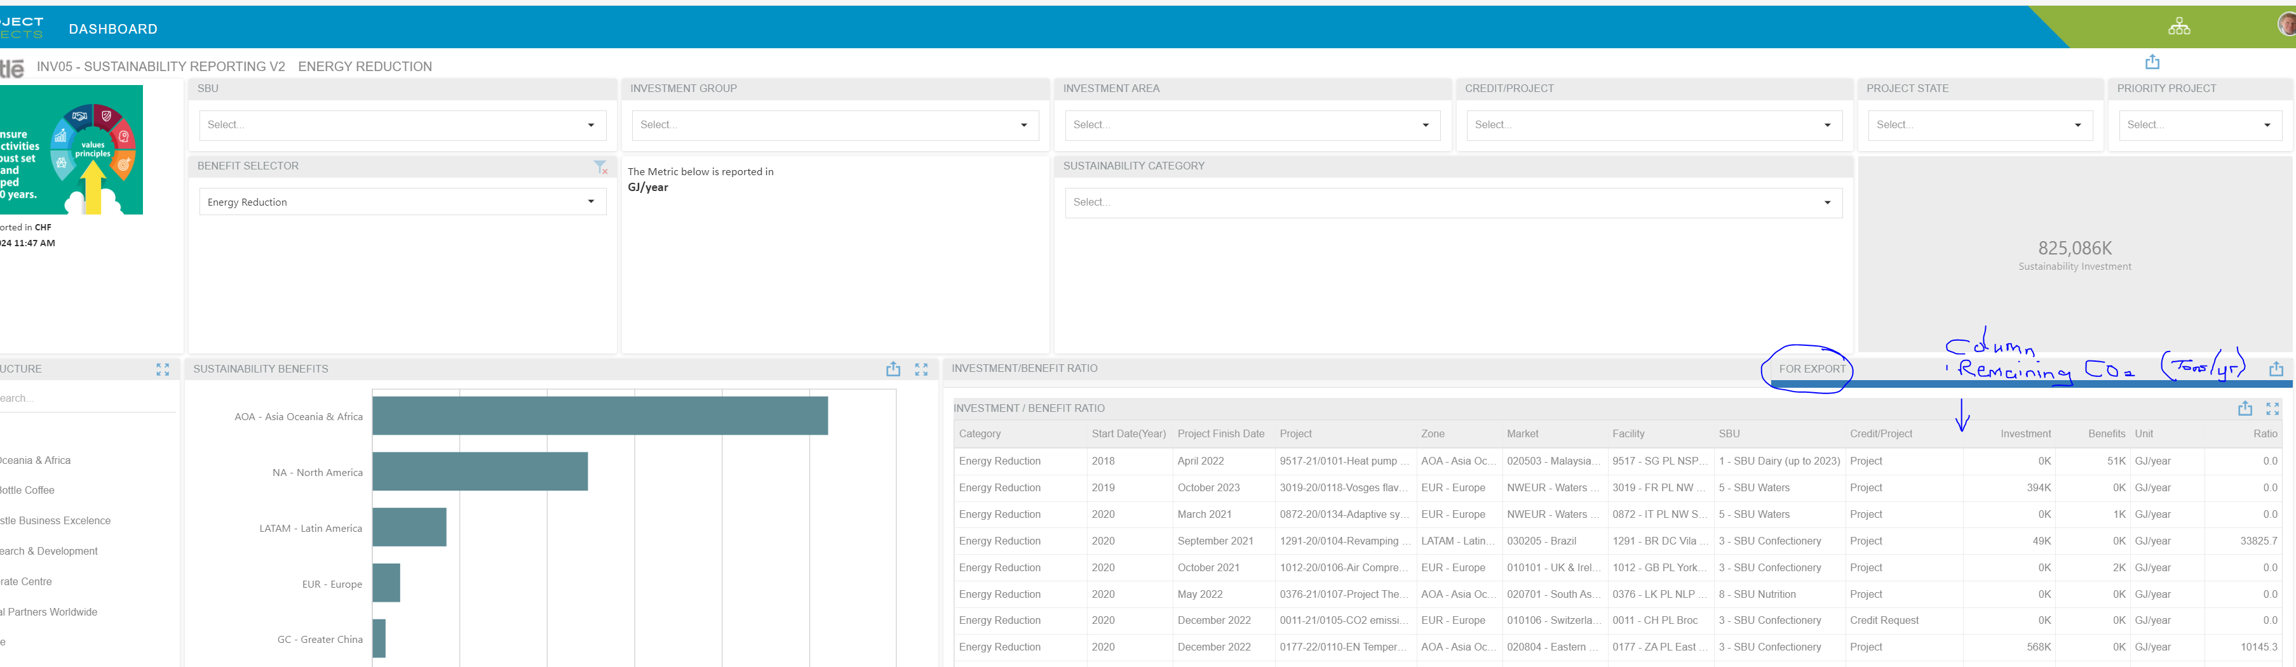

New widget to be added to the Benefit Management Tab

Benchmark Metrics

|  |  |  |  |
| --- | --- | --- | --- |
| Code | Description | Unit | Value |
| B01 | Annual Capacity of finished product (FP) from the new installation | MT/Year |  |
| B02 | BU018 - Industrial Service Building area | M2 |  |
| B03 | BU005 - Process Building area | M2 |  |
| B04 | BU006 - Logistics Building area | M2 |  |
| B05 | BU019 - Amenity Building area | M2 |  |
| B06 | No of pallet places in warehouse | Units |  |
| B07 | Estimated Annual Energy consumption of new installation (project scope) at full capacity | GJ/yr |  |
|  |  |  |  |

Building Area is expected to align with building cost (process unit level) in table below.

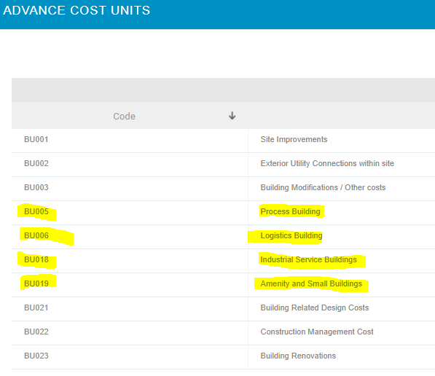

Dashboard / Reporting

Gather relevant data to one table suitable to export to excel. Template excel attached.